Exploring the Impact of Image Downscaling Algorithms on Color Perception

1st Bryan Myer Setiawan
Computer Science Department
School of Computer Science
Bina Nusantara University
Jakarta, Indonesia 11480
bryan.setiawan@binus.ac.id

4th Andry Chowanda
Computer Science Department
School of Computer Science
Bina Nusantara University
Jakarta, Indonesia 11480
achowanda@binus.edu
2nd Aura Kristian Sumowidjojo
Computer Science Department
School of Computer Science
Bina Nusantara University
Jakarta, Indonesia 11480
aura.sumowidjojo@binus.ac.id

3rd Anderies
Computer Science Department
School of Computer Science
Bina Nusantara University
Jakarta, Indonesia 11480
anderies@binus.ac.id

Abstract—Several image downscaling algorithms have been developed over the years, yet their impact on color perception after downscaling has not been thoroughly investigated. This study conducts various experiments to evaluate traditional and modern image downscaling algorithms and their effects on color preservation. Using the adapted method of Quantitative Color Pattern Analysis (QCPA), we objectively measure each algorithm’s performance in maintaining color perception. The algorithms compared include Bicubic Interpolation, Lanczos Resampling, Seam Carving, and Rapid Detail-Preserving Image Downscaling (RDPID) using the Imagenette and DIV2K datasets. Evaluation metrics encompass average color histogram similarity, dominant color shifts, and color scatter plots. Results reveal varying degrees of color information loss among the algorithms, with Bicubic Interpolation and RDPID showing superior color fidelity compared to Seam Carving. For the Imagenette dataset, average color histogram similarity between the original and downscaled images is 78.9% for Bicubic Interpolation, 75.8% Lanczos Resampling, 77.6% for RDPID, and 20.8% for Seam Carving. For the DIV2K dataset, the similarities are 65.7% for Bicubic Interpolation, 64.7% for RDPID, and 48.8% for Seam Carving. This research highlights the extent of color information loss due to the downscaling process across the chosen algorithms. Future studies should explore additional algorithms and assess their performance across diverse datasets and applications, enhancing our understanding of color information loss in image downscaling and its impact on computer vision tasks.
Keywords—Image downscaling, color perception, image downscaling algorithm, computer Vision, Quantitative Color Pattern Analysis

INTRODUCTION

Efficient image downscaling algorithms have become requisite to transform ultra-high-resolution images into a much smaller dimension while preserving the key features such as color perception [1], high contrast, and crisp boundaries of the original image. This downscaling process becomes crucial for training algorithms to solve computer vision tasks because it directly influences the computational costs of the algorithms. Therefore, a middle line must be met to achieve significant size reduction and maintain key features of the original image, particularly color accuracy. However, in the development of image classification algorithms, color is often overlooked. In addition, the exploration of the impact of color perception after the image downscaling process has not been thoroughly investigated.

Recent research on image downscaling proves that certain high features can be preserved at the downscaled result without any temporal artifacts. However, most of the experiments conducted require huge computational resources which can limit the practical use of real time. A recent research paper by Kanjar De and Marius Pedersen about the impact of color on the robustness of deep neural networks found that color information is an important factor in terms of computer vision tasks [2]. Hence, an experiment of several downscaling algorithms and analyzing the impact on color perception could be the answer to improve both computer vision tasks and problems of reducing the dimensions of pictures while still preserving their key features.

To enhance comprehension of the impact of image downscaling on color perceptions, we will conduct a series of experiments and compare the results quantitatively using the Quantitative Color Pattern Analysis (QCPA) method [3]. We will explore 4 downscaling methods/techniques starting from downscaling the images from the DIV2K and Imagenette dataset into the classic Lanczos resampling and Bicubic Interpolation and followed by the more recently proposed algorithms or techniques to show the relevance of our exploration of the color perception preservation post-downscaling images. Then, the downscaled and original images will be assessed through the QCPA-adapted methods and further image quality analysis, allowing us to examine the loss of color of each downscaling technique proposed.

LITERATURE REVIEW
A. Impact of Color

In the field of computer vision, algorithms or computers often require resizing of the input data or image, such as ultra-high resolution (UHR) images, to minimize the computing power requirements and maximize the accuracy of the output. [4] [2]. This method utilizes image transformation algorithms, widely known as downscaling algorithms to reduce the size of an image input data. These algorithms select a small number of specific colors or apply color palette reduction to downscale images, resulting in reduced loss of color information and affecting the color perception of the image itself. Therefore, object detection and image classification tasks in computer vision that are directly affected by its input image and the information that it contains will theoretically be influenced in terms of its performance.
Buhrmester et al. [4] have conducted experiments on the publicly available cifar10 and cifar100 datasets, containing 32x32 pixel images of animals, to find the significance of color and image quality towards the accuracy of classification algorithms. They concluded that images in some classes, such as deserts and animals, are highly dependent on the color information of an image.
Kanjar de and Marius Pedersen [2] have also conducted experiments exploiting the color information of the Imagenet datasets, pre-processed in 256x256 resolution, and tested it through several popular CNN architectures showing that this specific parameter has a relatively significant impact on the accuracy and bias of classification algorithms. The experiment is utilizing multiple state-of-the-art deep convolutional neural architectures of image classification. Through this experiment, they concluded that the Augmix technique and color information have a significant impact on the robustness of the training procedure. After observed in both EfficientNets (EfficientNetV1 and EfficientNetV2), higher resolution models are much more robust as the same trend (B7 has higher accuracy than B0 as well as V2L performs better than V2S) and NF-Nets. However, the disadvantage of this method is that it limits its effectiveness when color and contrast are the key features in robustness due to it not using any form of color augmentation.
Gowda S. and Yuan C. [5] also found out that color spaces significantly impact the image classification performance of deep learning algorithms like CNN by testing the existing algorithms with CIFAR-10, CIFAR-100, and ImageNet datasets, as well as proposed a new CNN model as a solution to address this problem. This previous research led us to inquire about the effect of image downscaling algorithms on the color information or perception of the image, which is the other end of pre-processing methods. [5]
B. Image Downscaling Algorithms
Image downscaling [6] [7] [8]aims at reducing resolution at minimum loss of quality. It is somewhat related to image compression but in lossy compression, some features or quality are irreversibly lost. There is still limited research regarding the impact of downscaling algorithms on color perception of images. Previous research [2] concludes that image downscaling algorithms can have a significant impact on the color accuracy and quality of the resulting image.
Starting with the classical algorithm of image transformation, the Lanczos resampling was introduced and designed to reduce the amplitude of aliasing in the downscaled image by filtering the image before resampling it, effectively removing high-frequency components that would cause the aliasing [9]. This filtering process helps maintain the integrity of the original image when downscaling it.
Other than the Lanczos resampling algorithm, the traditional image downscaling method that was commonly used was Bicubic Interpolation [7]. Bicubic interpolation-based image downscaling was widely used when a high-quality result is expected after the image downscaling process. However, this algorithm is somewhat prone to aliasing issues due to the loss of high-frequency details in the downscaling process. In addition, the most recently developed image-downscaling algorithms use Bicubic Interpolation as the base comparison of their results [10] [11] [12].
Avidan and Shamir [13] proposed a seam carving image operator method that supports content-aware image scaling for both image downscaling and upscaling. The seam carving process includes carving out or inserting seams in an image to change the image’s size while preserving the details. This method and result prove in an effective image detail preservation. This method can be used for image content enhancement or object removal. In addition, other research about seam-carving have been concluded by Han et al. [14]. Han et al. did a wavelet analysis which addresses the limitations of conventional seam carving techniques. This research also results in the downscaled image to still preserve the important semantic information and the shape of main objects in the scene.
Kim, S. and Kim, T. [15] proposed an enhanced version by removing the noise amplification of the previously proposed Rapid, Detail-Preserving Image Downscaling (RDPID) [16]. They utilized a two-step one-dimensional inverse joint bilateral filtering and an area pixel model to achieve a fast downscaling while maintaining the important features of the original image. However, the paper only suggests superiority over existing techniques, a more comprehensive evaluation using quantitative metrics like PSNR and SSIM is not explicitly mentioned.
Due to the filter not being able to adapt to the content of images when downscaling, a content-adaptive technique [17] was proposed later to overcome this problem through adapting the shape and location to achieve better downscaling images. SSIM or Structural Similarity Index Method [18] was later introduced in response to the rising improvement of content-adaptive technique and serves as the perceptual image quality matrix. It compares two images by calculating the differences in luminance, contrast, and structural information and gives either a score of 0 or 1 to represent whether the two images are identical or completely different. This method was widely used and useful as it can help identify the algorithm that best preserves the structural information and visual quality of the original image.
Recent research of downscaling algorithm was proposed by Pack C. et al. [19] in 2023, a method for adaptive image downscaling that is guided by perceptual cues to enhance the performance of semantic segmentation tasks on large document images, focusing on preserving important features such as crisp boundaries and high contrast of the image. They also demonstrated further testing by using three different training scenarios: stand-alone, image-pyramid, and augmentation. As a result, the proposed method was proven to be effective when tested into a deep learning-based document image segmentation pipeline and compared to a few other downscaling methods like Lancsoz [9].
C. Quantitative Color Pattern Analysis
Quantitative Color Pattern Analysis (QCPA) [3] is a comprehensive approach to the study and analysis of color patterns through statistical data. QCPA dynamic framework can be viewed as a template to solve the quantitative and qualitative limitation of existing color pattern analyses by combining digital photography and visual modeling. QCPA methods include modeling of spatial faculty using Fast Fourier transform of Gaussian filter, image smoothing and edge reconstruction using receptor noise limited ranked filter, image segmentation using receptor noise limited clustering and naive bayes clustering, pattern analysis, and data visualization. These quantitatively scaled workflow can’t be considered as a ‘perfect’ solution; however, it can provide an idea on how to scale different elements of vision modeling and color patterns analysis through existing methods.

PROPOSED METHOD
- Dataset
Generally, datasets used to train classification or object detection algorithms already contain relatively small sized images with pixels around 32x32 up to 256x256 to lower the computing power needed. Therefore, in this experiment we utilized 2 different datasets. Firstly, the DIV2K dataset, containing 1000 2K resolution images divided into 3 subsets of train, validation, and test sets [20]. This dataset also contains low-resolution images produced using bicubic_x2, bicubic_x3, and bicubic_x4 downscaling algorithms. Due to this dataset providing both high- and low-resolution images, it is a perfect fit towards our experiment in finding the impact of downscaling algorithms on color perception, in which we can use the already downscaled images using the bicubic algorithm or use the raw high-resolution image and downscale it using other image downscaling algorithm to generalize the result in loss of color information.
In addition, we also utilize the Imagenette dataset which is a subset of the larger ImageNet dataset [21]. This dataset contains 13394 images spanning 10 different classes from diverse sources and resolutions and divided into 3 subsets of train, validation, and test sets. This dataset is considered as one of the best resources for training, validating, and testing image classification models which have limited computational resources.
- Image Downscaling Algorithm
As previously discussed in the literature review, several downscaling algorithms were used to measure the significance of color information loss of the downscaled images to reduce bias and generalize the results. This downscaling algorithm includes [9] [7] [13] [14] [16]:
- Lanczos resampling
- Bicubic interpolation
- Seam Carving
- Rapid, detail-preserving image downscaling (RDPID)

However, in this experiment we focus on the x1/5 image downscaling in size due to the normal training input size of classification algorithms being around 32x32 up to 224x224 pixels.
- Data Collection and Analysis
In this research, we extracted color features from the original and downscaled images to compare the color information loss using methods adapted from the proposed method called Quantitative Color Pattern Analysis (QCPA) framework [3] by Cedric P. van den Berg and Jolyon Troscianko. Specifically, we employed color histograms to measure the distribution of colors in the RGB color space, providing insights into the preservation or loss of color information during downscaling. Additionally, we analyzed dominant color shifts using pie charts to visualize changes in the most prevalent colors between the original and downscaled images. Furthermore, color scatter plots were utilized to compare the spread and density of color distributions, helping to identify any significant deviations or clustering effects caused by the downscaling process. These combined methods offer a comprehensive evaluation of the color fidelity and transformation occurring due to the downscaling techniques in the RGB color space. To further understand the impact on image quality, we included Visual Information Fidelity (VIF), Peak Signal-to-Noise Ratio (PSNR), and Structural Similarity Index (SSIM), which provide additional metrics to assess the overall image quality post-downscaling.
- RESULT AND DISCUSSION
Based on the experiment results, color loss can be assessed through average histogram similarities, dominant color shifts, and quantitative measures such as VIF, PSNR, and SSIM. Bicubic Interpolation and RDPID show higher color fidelity, while Seam Carving exhibits the most significant color information loss.
  - Qualitative Approach of Image Downscaling
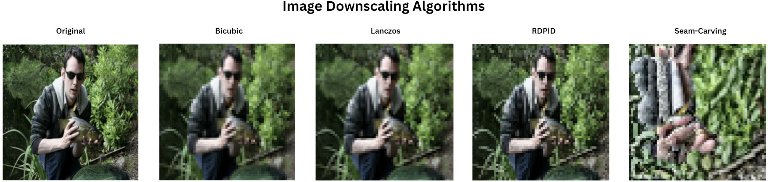
Figure 1: Downscaled Imagenette visualization.
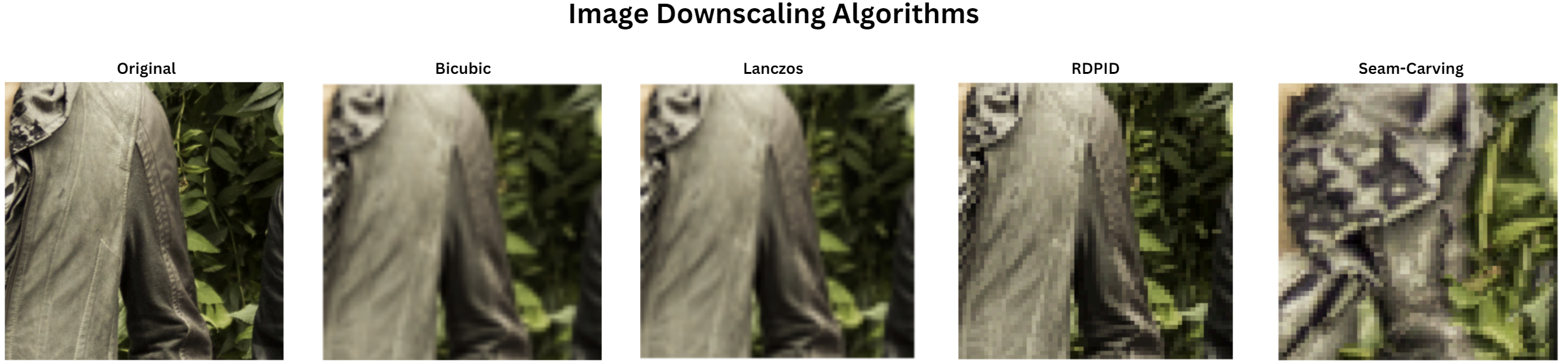
Figure 2: Downscaled DIV2K visualization.
Figure 1 and Figure 2 presents a comparative visualization of image downscaling results using the original image, and four other image downscaling results: Bicubic Interpolation, Lanczos Resampling, Seam Carving, and Rapid Detail-Preserving Image Downscaling (RDPID) on both datasets. Each result demonstrates unique upside and downsides as below. The original image serves as a benchmark to assess the retention of image detail and color accuracy.
Bicubic Interpolation has the best visual representation with a relatively smooth result. However, this comes at the cost of losing some sharpness and details shown in the noticeable blurring around edges and fine structures.
Lanczos Resampling maintains sharper edge preservation compared to Bicubic Interpolation but it results in ringing artifacts, visible as slight halos around high-contrasts edges.
Seam Carving does not have the best result as can be seen in both Figure 1 and 2. This is due to the algorithm’s priority to preserve important content and structures by removing less significant pixels, leading to noticeable artifacts and a less natural appearance.
Rapid Detail-Preserving Image Downscaling (RDPID) shows a high level of detail retention and color fidelity, producing an optimal balance between edge preservation, color fidelity, and minimal artifacts. As seen in both Figure 1 and 2, RDPID maintains the integrity of fine details and minimizes color distortions, making a robust choice of downscaling.
  - Quantitative Approach of Image Downscaling
To further examine color information loss, we adopted the QCPA method and specifically analyzed the image through color histograms, dominant color shifts, and color scatter plots.
    - Color Histogram
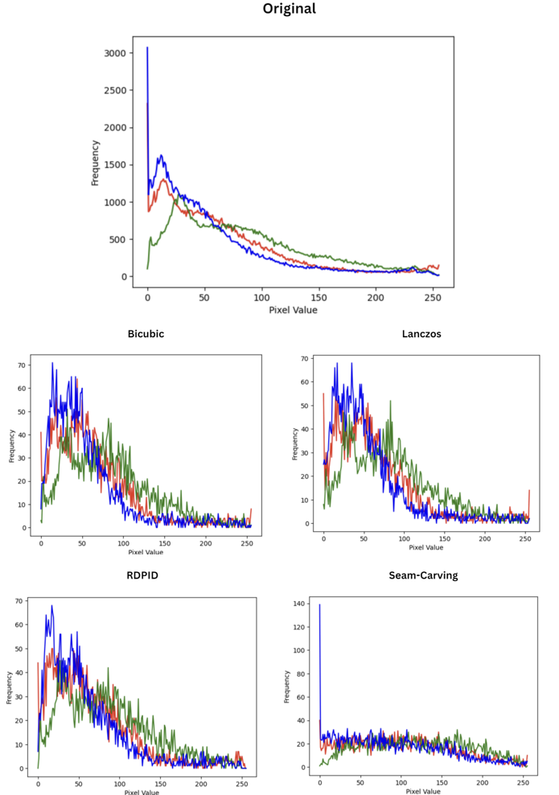

Figure 3: Downscaled Imagenette Color Histogram

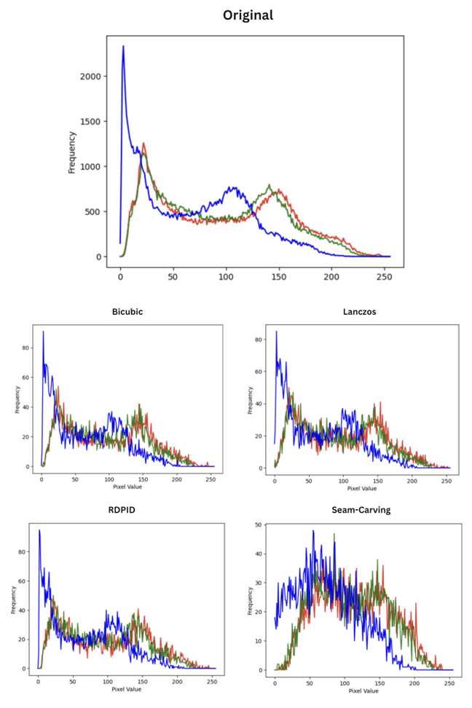

Figure 4: Downscaled DIV2K Color Histogram

TABLE I

Average Histogram Similarity Comparison Between Downscaling Algorithms with Imagenette Dataset
Downscaling Algorithm | Average Histogram Similarity
Bicubic Interpolation | 0.77921
Lanczos Resampling | 0.75813
Seam Carving | 0.20821
Rapid, Detail-Preserving Image Downscaling (RDPID) | 0.77597

TABLE II

Average Histogram Similarity Comparison Between Downscaling Algorithms with DIV2K Dataset
Downscaling Algorithm | Average Histogram Similarity
Bicubic Interpolation | 0.65723
Lanczos Resampling | 0.65095
Seam Carving | 0.48769
Rapid, Detail-Preserving Image Downscaling (RDPID) | 0.64696
The color histogram in Figure 3 and 4 helps us evaluate the effectiveness of the four-image downscaling method the Imagenette and DIV2K datasets quantitatively. Color Histogram provides a graphical representation of the distribution of colors across different color channels (red, green, and blue) in an image to understand the impact of color information preservation. In addition, from Table 1 and Table 2, the average histogram similarity represents the numerical representation of the color histogram shown.
Bicubic Interpolation has a characteristic of a smoother and narrower histograms compared to the original images. Having the highest score of average histogram similarity of 0.779 from the Imagenette and 0.657 from the DIV2K dataset, indicates that Bicubic Interpolation preserves the color information from the original image well.
Lanczos Resampling produces a broader histogram and exhibit more peaks compared to Bicubic. This algorithm also produces an average histogram similarity of 0.758 from the Imagenette and 0.650 from the DIV2K dataset. This indicates a better preservation of edges and other fine details but introduces changes in color distribution.
Seam Carving displays significant deviations with unpredictable patterns in the distribution of the color intensities. This algorithm also produced the lowest average histogram similarity among other algorithms of 0.208 through Imagenette and 0.487 through DIV2K dataset. The low similarity score reflects the substantial removal/ shifts in color intensity which are captured in the histogram shown in Figure 3 and 4.
Rapid Detail-Preserving Image Downscaling (RDPID) produced a histogram that matches closely to the original, preserving both the color intensity and range indicating in a minimal color deviation. With an average histogram similarity score of 0.776 through Imagenette and 0.647 through DIV2K dataset, slightly lower than Bicubic.
    - Dominant Color Shift

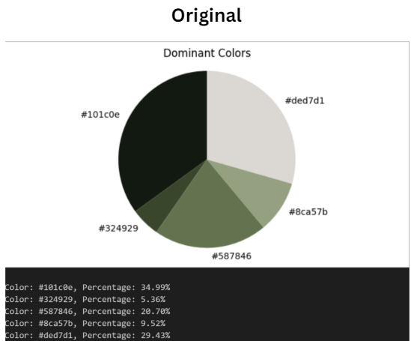

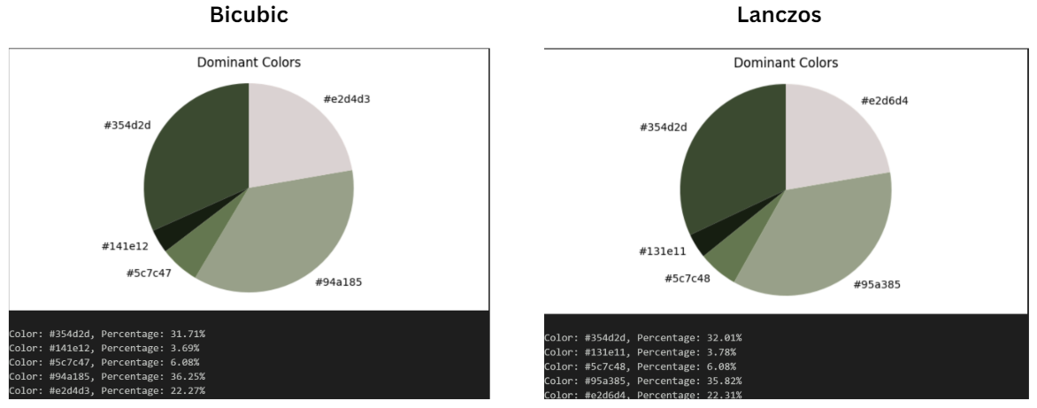

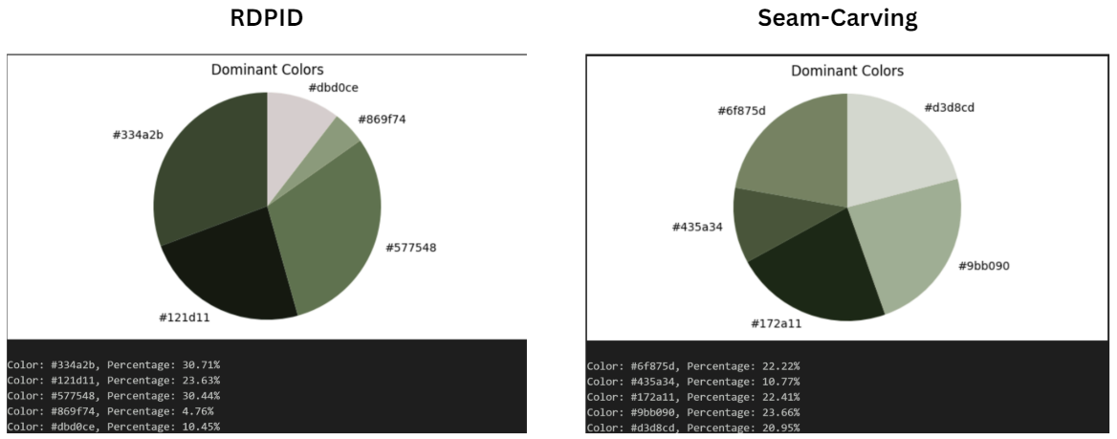

Figure 5: Downscaled Imagenette Dominant Color Pie Chart
Dominant Color Shift analysis, visualized using pie charts, allows us to examine the dominant colors changes in the images comparing the original and downscaled results. This method may provide an insight into how each method affects the overall color percentages of an image.
Bicubic Interpolation results in slight shifts towards blues and green, losing some vibrancy in warmer color hues which may indicate a less preferred algorithm when color warmth or balance is crucial. This can be seen through Figure 5, which the original image has the color: #101c0e with the percentage of 34.99% shifting to a greener dominant color: #94a185 with the percentage of 36.25%.
Lanczos Resampling maintains a color distribution that is somewhat like the original. However, a slight increase of certain color hues can be seen such as in red and green, indicating that a minor alteration in the overall color balance which may result in certain hues being enhanced but can also cause problematic results respectively when a precise color accuracy is needed. This can be seen through the sample in Figure 5 in which the downscaled result shifts in a greener dominant color: #95a385 with the percentage of 35.82%.
Seam Carving introduces noticeable shifts in the dominant colors compared to the other algorithms. Often favoring different color hues for different images, resulting in an uneven distribution. Due to this, Seam Carving is a less reliable algorithm to maintain the original color balance of an image. An example is provided in Figure 5 in which the downscaled result shifts in a greener dominant color: #9bb08f with the percentage of 23.56%.
Rapid Detail-Preserving Image Downscaling (RDPID) maintains a minimal color shift after being downscaled from the original image and most color hues are in a small range of difference. This indicates that RDPID effectively preserves the overall color balance making this algorithm suitable for image downscaling algorithm that require high color fidelity. An example is provided in Figure 5 in which the downscaled result shifts in a greener dominant color: #334a2b with the percentage of 30.71%.
    - Image Color Scatter

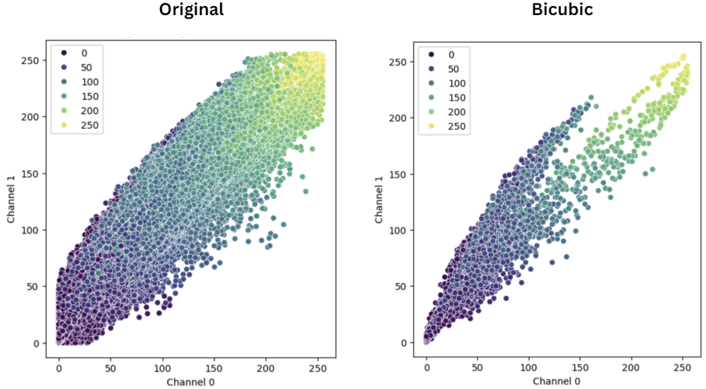

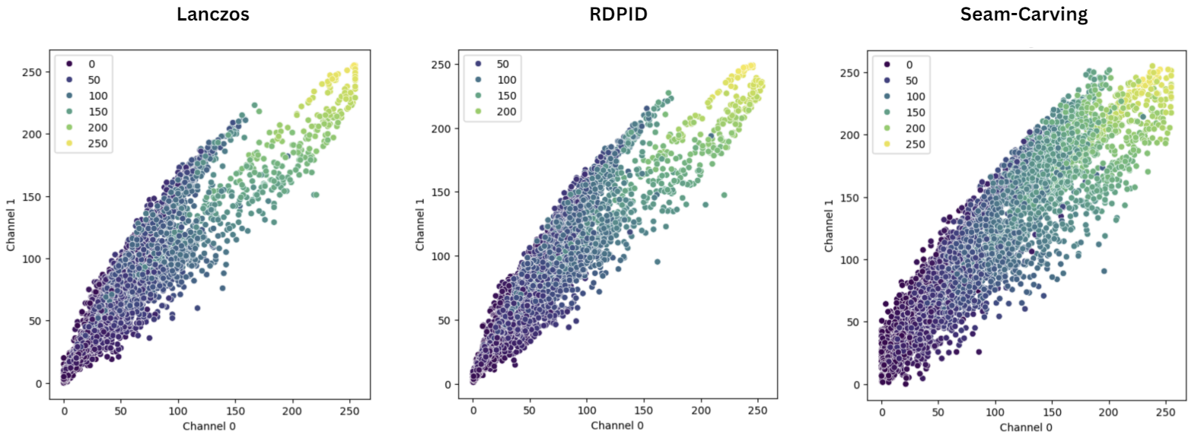

Figure 6. Downscaled Imagenette color scatter plot
Image color scatter provides a representation of the distribution and clustering of color in the image. Each plot represents the corresponding color, and the position is determined by the RGB values. The visualization helps analyze how various downscaling algorithms affect the spread and clustering of colors resulting in a diverse color distribution.
Bicubic Interpolation was able to maintain the overall color structure of the original image but results in a more compact color distribution. As shown in Figure 6, the original image displays a broad and even distribution of colors with points scattered across the RGB spectrum, while Bicubic loses some color variation and have a more uniform palette.
Lanczos Resampling preserves a broad spread with more distinct clusters, similar to the original. The color distribution is well preserved with only slight enhancements in certain areas. The algorithm retains the natural color variations while enhancing the image edges making it more suitable for HR images with critical details.
Seam Carving presents an uneven distribution and varied cluster sizes. This is due to the method focusing more on content preservation, leading to a significant alteration in color diversity and distribution. The scatter plot reflects the uneven color preservation, making Seam Carving less suitable for applications requiring consistent color representation.
Rapid Detail-Preserving Image Downscaling (RDPID) represents a close match color scatter to the original image, representing a wide and even color distribution. Clusters are also well-preserved indicating a minimal color loss. This indicates that RDPID will be ideal where the downscaled result requires a better image quality and color fidelity.
  - Additional Metrics of Image Quality
TABLE III
Additional Metrics Comparison Between Downscaling Algorithms
Downscaling Algorithm | VIF | PSNR | SSIM
Bicubic Interpolation | 0.55224 | 24.0233 | 0.76328
Lanczos Resampling | 0.58521 | 24.1534 | 0.76693
Seam Carving | 0.11232 | 9.8111 | 0.26133
Rapid, Detail-Preserving Image Downscaling (RDPID) | 0.61074 | 23.7717 | 0.76824
In Table 3, each downscaling algorithm demonstrated the different average values of VIF, PSNR, and SSIM when tested on the datasets.
Bicubic Interpolation demonstrated good overall performance VIF of 0.55224, PSNR of 24.0233, and SSIM of 0.76328, indicating that Bicubic Interpolation effectively preserves image detail and color fidelity, making it a reliable method for general use. The VIF score shows a moderate ability to retain the visual information content of the images. In contrast, the PSNR and SSIM scores suggest good similarity to the original images in terms of both pixel-wise and structural aspects.
Lanczos Resampling showed slightly better VIF (0.58521) and PSNR (24.1534) than Bicubic Interpolation, with SSIM of 0.76693, showing that Lanczos Resampling not only preserves details and edges more effectively but also maintains color fidelity close to the original images. The slightly higher VIF suggests better retention of visual information content, and the PSNR and SSIM scores reflect strong performance in pixel-level and structural similarity measures.
Seam Carving performed poorly with VIF of 0.11232, PSNR of 9.8111, and SSIM of 0.26133, reflecting significant color information loss and artifacts. The low VIF score indicates a substantial loss of visual information content. In contrast, the PSNR and SSIM scores highlight severe degradation in pixel-wise and structural similarity, making Seam Carving unsuitable for applications where color fidelity and detail preservation are critical.
Rapid Detail-Preserving Image Downscaling (RDPID) achieved the highest VIF (0.61074) and SSIM (0.76824) with a PSNR of 23.7717, slightly lower than Bicubic Interpolation and Lanczos Resampling. This shows its ability to retain details and color accuracy effectively. The high VIF score demonstrates excellent preservation of visual information content, and the strong SSIM score indicates superior structural similarity. Although the PSNR is slightly lower than that of Lanczos Resampling, RDPID's overall performance makes it a robust choice for high-quality downscaling with minimal color and detail loss.
  - Comparison with Previous Research
Comparing our results with previous studies, our findings align with the literature regarding the strengths and weaknesses of each downscaling algorithm. Bicubic Interpolation and Lanczos Resampling are preserving color fidelity and detail retention consistently [16]. Seam Carving's limitations are also noted in previous research [14] [13], highlighting its significant color fidelity issues and artifacts, making it less suitable for tasks requiring accurate color preservation. Recent advancements in downscaling techniques corroborate RDPID's effectiveness in balancing detail retention and color fidelity [16].
- CONCLUSION
In conclusion, our study demonstrates that Rapid Detail-Preserving Image Downscaling (RDPID) provides the best balance between detail retention and color fidelity among the algorithms tested both quantitatively and qualitatively, making it the most robust method in our study for preserving both detail and color fidelity. Bicubic Interpolation and Lanczos Resampling also perform well but exhibit certain limitations in color preservation and artifact generation. On the other hand, Seam Carving shows significant deviations in color fidelity and is not recommended for tasks requiring high color accuracy.
Overall, this research highlights the color information loss due to the downscaling process through the chosen algorithms. Future research should explore other algorithms, use larger datasets, and perform detailed color harmonization analysis. Incorporating quantitative metrics like color histogram similarity, VIF, PSNR, and SSIM provides a comprehensive evaluation of downscaling techniques, and further studies could refine these approaches for specific applications in computer vision and image processing. In addition, the models provided can be tested in several Convolutional Neural Networks (CNNs) to further examine the significance in the real-world applications.

REFERENCES

[1] | K. R. G. Christoph Witzel, "Color Perception: Objects,," Annual Review of Vision Science, vol. 4, pp. 475-499, 2018.
[2] | M. P. Kanjar De, "Impact of Colour on Robustness of Deep Neural Networks," Proceedings of the IEEE International Conference on Computer Vision, pp. 21-30, 2021.
[3] | J. T. J. A. E. N. J. M. K. L. C. Cedric P van den Berg, "Quantitative Colour Pattern Analysis (QCPA): A comprehensive framework for the analysis of colour patterns in nature," Methods in Ecology and Evolution, vol. 11, no. 2, pp. 316-332, 2020.
[4] | B. V. D. D. e. al., "Evaluating the Impact of Color Information in Deep Neural Networks," Lecture Notes in Computer Science, vol. 11867, p. 302–316, 2019.
[5] | C. Y. Shreyank N Gowda, "ColorNet: Investigating the Importance of Color Spaces for Image Classification," Lecture Notes in Computer Science, vol. 11364, p. 581–596, 2019.
[6] | S. M. K. K. P. C. Y. P. C. L. J. L. Jaehwan Kim, "HIGH-FREQUENCY PRESERVING IMAGE DOWNSCALER," Proceedings - International Conference on Image Processing, ICIP, 2021.
[7] | Z. C. Wanjie Sun, "Learned Image Downscaling for Upscaling Using Content Adaptive Resampler," Li WNi LLi ZDuan SWu H, pp. 4027-4040, 2020.
[8] | C. A. B. Dragos Dumitrescu, "A study of image upsampling and downsampling filters," Computers, vol. 8, no. 2, p. 30, 2019.
[9] | H. D. Simon, "The Lanczos Algorithm With Partial Reorthogonalization," Mathematics of Computation, vol. 142, pp. 115-142, 1984.
[10] | G. R. W. T. Donatella Occorsio, "Lagrange–Chebyshev Interpolation for image resizing," Mathematics and Computers in Simulation, vol. 197, pp. 105-126, 2022.
[11] | D. Z. J. Z. R. X. a. Yongbing Zhang, "Interpolation-Dependent Image Downsampling," IEEE TRANSACTIONS ON IMAGE PROCESSING, vol. 20, pp. 3291-3296, 2011.
[12] | T.-H. W. C.-T. C. Wei-Chen Wu, "Edge Curve Scaling and Smoothing with Cubic Spline," J Sign Process Syst, vol. 78, pp. 95-113, 2015.
[13] | a. A. S. Shai Avidan, "Seam Carving for Content-Aware Image Resizing," Seminal Graphics Papers: Pushing the Boundaries, vol. 2, no. 3, pp. 609-617, 2023.
[14] | K.-S. C. T.-S. W. S.-H. C. a. S.-J. K. Jong-Woo Han, "WAVELET BASED SEAM CARVING FOR CONTENT-AWARE IMAGE RESIZING," 2009 16th IEEE International Conference on Image Processing (ICIP), pp. 345-348, 2009.
[15] | T. S. K. Su Hyon Kim, "A New Rapid and Detail-Preserving Image Downscaling Without Noise Amplification," IEEE Access, vol. 10, pp. 107032 - 107042, 2022.
[16] | M. W. S. C. A. S. G. M. G. Nicolas Weber, "Rapid, Detail-Preserving Image Downscaling," ACM Transactions on Graphics, vol. 35, no. 6, pp. 1-6, 2016.
[17] | Johannes Kopf, Ariel Shamir, Pieter Peers, "Content-Adaptive Image Downscaling," ACM Transactions on Graphics, pp. 1-8, 2013.
[18] | A. C. B. Ming-Jun Chen, "Fast structural similarity index algorithm," Journal of Real-Time Image Processing, vol. 6, p. 281 – 287, 2011.
[19] | L. K. S. E. L. Chulwoo Pack, "Perceptual cue-guided adaptive image downscaling for enhanced semantic segmentation on large document images," International Journal on Document Analysis and Recognition, pp. 1 - 17, 2023.
[20] | Tensorflow Datasets, "Imagenette Dataset," Google, 6 December 2019. [Online]. Available: https://www.tensorflow.org/datasets/catalog/imagenette. [Accessed 23 July 2024].
[21] | E. A. a. R. Timofte, "DIV2K Dataset," 20 September 2017. [Online]. Available: https://data.vision.ee.ethz.ch/cvl/DIV2K/. [Accessed 23 July 2024].

